Week 6

1.ReactJS HOL

**Define SPA (Single-Page Application) and its Benefits**

* **SPA** is a web application that loads a single HTML page and dynamically updates content without reloading the page.
* Uses JavaScript to fetch data and update the UI.

**Benefits of SPA:**

* Faster navigation between pages.
* Reduces server load.
* Smoother user experience (like a mobile app).
* Efficient data handling using APIs (e.g., REST, GraphQL).

**Define React and Identify Its Working**

* **React** is a JavaScript library used for building user interfaces, especially for single-page applications.
* Developed by Facebook.
* Component-based architecture.

**How React Works:**

* Uses **JSX** to write HTML in JavaScript.
* Breaks UI into reusable components.
* Uses **Virtual DOM** for efficient UI updates.
* React compares changes and updates only the changed parts in the DOM.

**Differences Between SPA and MPA (Multi-Page Application)**

| **Feature** | **SPA** | **MPA** |
| --- | --- | --- |
| Page Load | Single load, dynamic content | Loads new page every time |
| Speed | Faster navigation | Slower due to full reloads |
| Development | More dependent on JS | More server-side rendering |
| User Experience | Smooth, app-like | Traditional, less dynamic |
| SEO | Harder (can be managed) | Easier to handle SEO |

**Pros & Cons of Single-Page Application (SPA)**

**Pros:**

* Fast and responsive.
* Reduces server requests.
* Better user experience.
* Reusable front-end components.

**Cons:**

* Poor SEO (needs extra setup).
* Initial load time can be high.
* JavaScript must be enabled in the browser.
* Complex to secure and manage routes.

**Explain About React**

* Open-source JS library for UI development.
* Handles view layer in web and mobile apps.
* Works with virtual DOM.
* Supports **component-based** architecture.
* Enables efficient rendering using React hooks and state.

**Define Virtual DOM**

* **Virtual DOM** is a lightweight copy of the actual DOM.
* React uses it to track changes and update only the parts of the real DOM that changed.
* Improves performance by reducing DOM manipulation.
* Uses **diffing algorithm** to compare changes.

**Features of React**

* **Component-Based:** Break UI into reusable pieces.
* **Virtual DOM:** Fast and efficient updates.
* **JSX:** JavaScript + HTML-like syntax.
* **One-Way Data Binding:** Data flows in one direction (top to bottom).
* **Hooks:** Add state and side-effects in functional components.
* **Performance:** Faster UI with minimal DOM changes.
* **Strong Community:** Backed by Facebook and large developer support.
* **React Native:** Build mobile apps using React.

Steps:

App.js :-

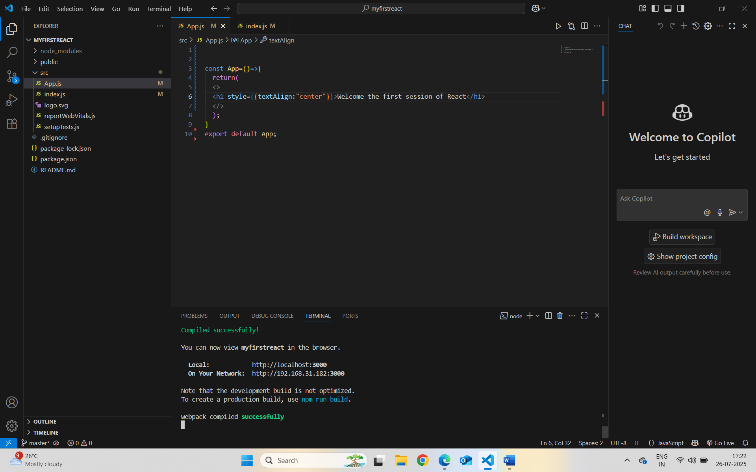

npm start in terminal:-

Localhost:3000 :-

